Preliminary static analysis
02/01/2026
Danny LeBlond
CNG4054X00 Malware Threats and Analysis

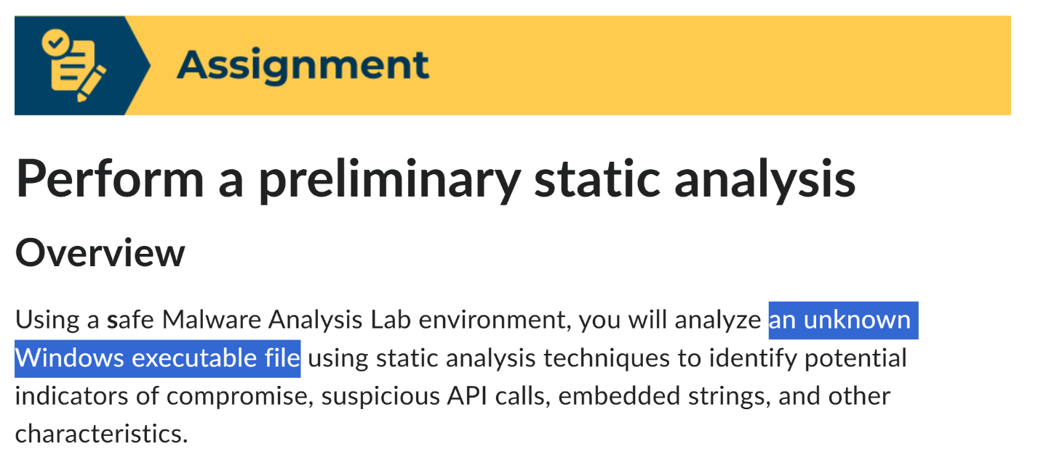The file analyzed was Lab01-01.exe, which is a Windows Portable Executable file from the Practical Malware Analysis Labs GitHub repository. The analysis was done using static analysis only, meaning the file was not opened or run. All work was performed inside an isolated Windows virtual machine with network access disabled to prevent any possible harm to the host system or the internet. This setup ensures the analysis is safe while still allowing important information about the file to be examined.
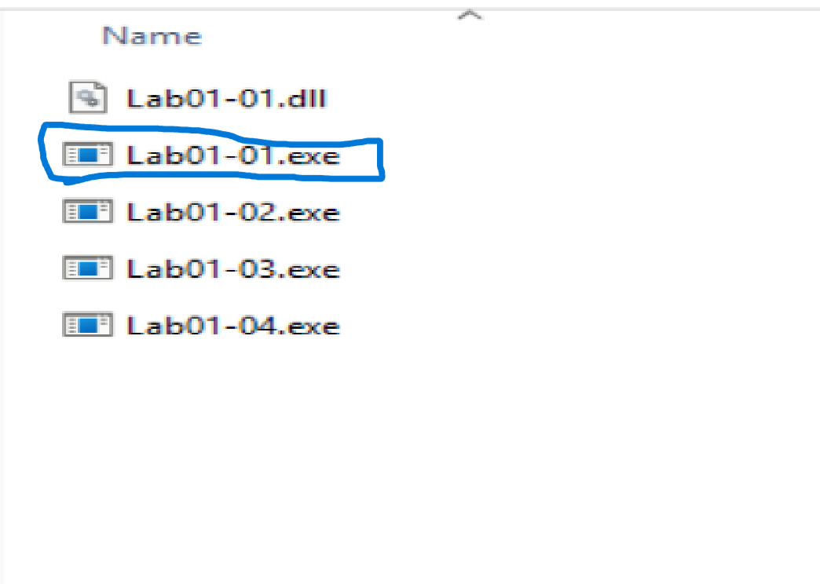

File Properties
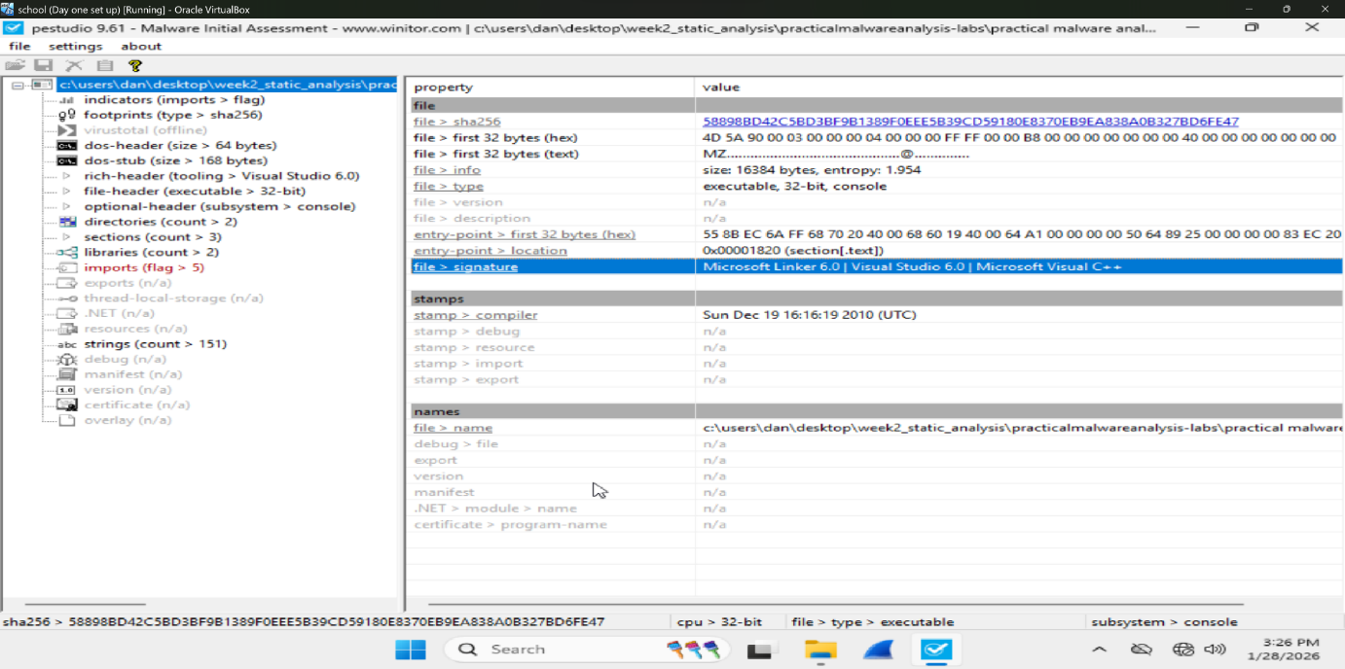
PEStudio shows that this file is a 32-bit Windows program that runs as a console application, meaning it runs using the command line instead of opening a normal window with buttons. The file size is 16,384 bytes, which is pretty small. The file has an entropy value of 1.954, which is considered low. Entropy is a measurement of how random or scrambled a file’s data is, and it is usually measured on a scale from 0 to about 8. Values closer to 0 mean the data is very predictable and easy to read, while values closer to 7–8 mean the data is highly random. Files that are packed or encrypted often have high entropy because their contents are scrambled to hide what the program does. Since this file’s entropy value is 1.954, which is much closer to 0 than 8, it suggests the file is not packed or encrypted. This means the file’s contents are more readable and easier to analyze. This is a clue that the program was likely left in a simple, unprotected form, which is common for early stages or unsophisticated malicious programs (or educational malware samples).

File Signature and Compiler Information
PEStudio also shows the file was built using Microsoft Linker 6.0 and Visual Studio 6.0 (Microsoft Visual C++), which are older Microsoft tools. This gives a clue that the program was likely compiled using legacy development software, which can be common in older malware (or educational lab files). This suggests the program was created using older development practices and may lack modern security features, making it easier to analyze and understand during static analysis.

Timestamps
The compiler timestamp is Sunday, December 19, 2010 (UTC). Even though timestamps can be changed, this date matches when these lab files were created, so it does not stand out as suspicious. This gives a clue that the file was likely created around the same time as the original lab materials and was not recently modified or recompiled, which supports the idea that this sample is an older, intentionally provided training file rather than a newly developed piece of malware.

Observations
Overall, the information gathered so far provides several useful clues about this file. Its small size, low entropy value, and lack of packing or encryption suggest the program was intentionally left easy to read and analyze. The use of older Microsoft development tools and a 2010 compiler timestamp further indicate that this file is likely an older sample created using legacy practices. Taken together, these clues suggest the file is not heavily protected or modernized, making it well suited for educational purposes and for continued static analysis by beginners.

Imports:
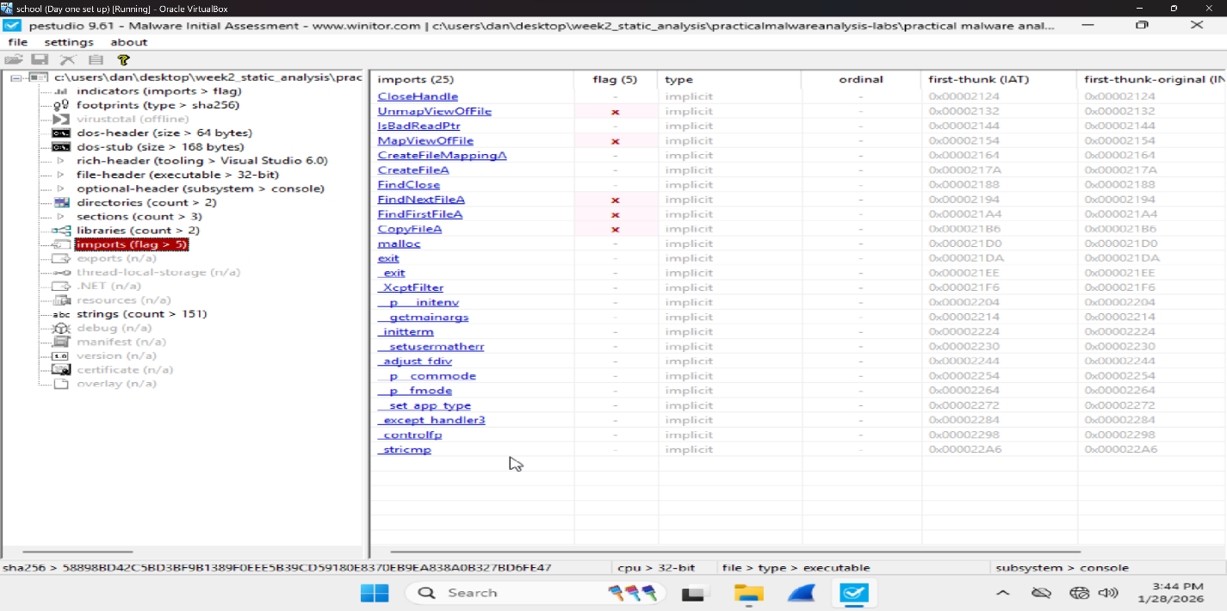
In this step, I reviewed the Imports section in PEStudio. Imports show which Windows functions the program plans to use. This is like seeing a list of “tools” the program brought with it. The program has 25 imports, and PEStudio flags the imports list (shown as imports (flag > 5)), which means multiple imported functions are considered suspicious or worth looking at.

Flagged Imports
Below are the imports that stand out the most because they relate to file access, file copying, and searching directories:
CreateFileA
CreateFileA is used to open existing files or create new ones on disk. This matters because programs that use this function are able to read from files, write new data, or create new files entirely. Seeing this import gives a clue that the program actively interacts with the file system rather than just running in memory.

CopyFileA
CopyFileA allows the program to copy a file from one location to another on the system. This matters because malware often uses file copying to move itself to different folders in order to hide or to stay on the system longer. Seeing this import gives a clue that the program may duplicate itself or copy other files as part of what it does.
FindFirstFileA / FindNextFileA / FindClose
The functions FindFirstFileA, FindNextFileA, and FindClose work together to search through folders and list files on the system. This matters because programs that search directories are often looking for specific targets, such as documents, configuration files, or other executable files. Seeing these imports gives a clue that the program may scan the file system to locate certain files before deciding what action to take.

Other Imports:
Some imports are not automatically flagged but they give strong hints about how the program works:
CreateFileMappingA / MapViewOfFile / UnmapViewOfFile
These functions allow the program to load a file directly into memory instead of reading it line by line. This matters because memory mapping is often used when a program needs to quickly read, inspect, or work with the contents of a file. Seeing these imports gives a clue that the program may process file contents directly in memory rather than only opening or copying files.
IsBadReadPtr
IsBadReadPtr is used to check whether a memory address is safe to read before the program tries to use it. This function appears more often in older code and is commonly used to prevent crashes. Its presence gives a clue that the program may perform low-level memory operations and includes checks to make sure memory access does not cause errors.

malloc
The function malloc is used to allocate memory while the program is running. This means the program can create and manage data dynamically instead of using fixed values. This gives a clue that the program builds or stores information as it runs, which is normal for common malware.
strcmp
The strcmp function is used to compare strings. This matters because string comparisons are often used to check file names, file paths, or commands. Seeing this import gives a clue that the program uses decision-making logic based on text values.
CloseHandle
CloseHandle is used to properly close files, processes, or other system resources after they are used. This shows the program is managing Windows resources correctly. This gives a clue that the code is intentionally written and functional, rather than broken or incomplete.

Overall right now all of these imports together suggest that the program is mainly designed to work with files on the system. It looks like it can search through folders, open files, copy them, and read their contents. When this is combined with what we saw earlier in Step 1 (small file size, low entropy, and a console-based program), it looks like a simple program that does one main job related to handling files. At this point these clues suggest the file could be harmful depending on what files it looks for and where it copies them.
STRINGS ANALYSIS:
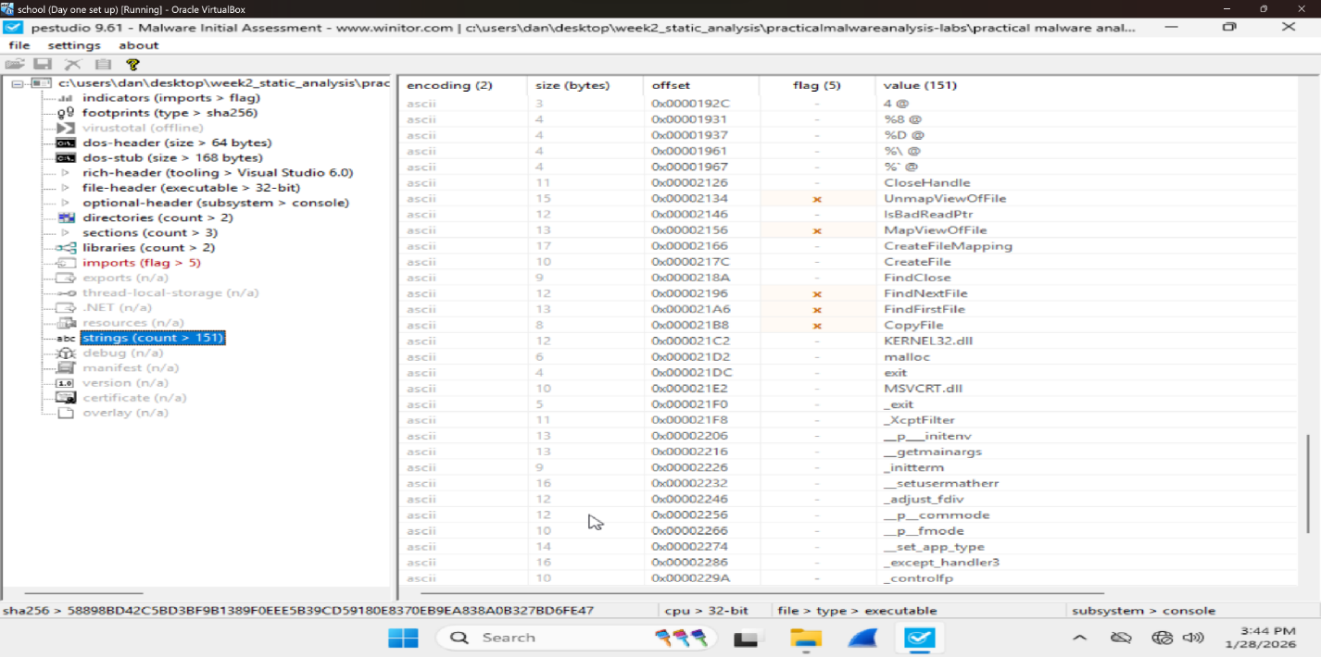

Strings are readable words inside a program that can give clues about what it does. PEStudio found 151 readable strings, which matches the earlier low entropy result. This means the file is not packed or encrypted and is easy to look at. Several strings were flagged because they deal with files and memory. For example, CreateFile shows the program can open or create files on the system. CopyFile suggests the program can copy files, which malware sometimes does to spread or stay on a computer. The strings FindFirstFile and FindNextFile show the program can search through folders and list files. Another flagged string, MapViewOfFile, means the program can load files into memory and read their contents instead of just moving them. One important thing missing is internet-related strings. There were no URLs, IP addresses, or web commands found, which suggests the program does not use the network. The strings show that this program mostly works with local files, such as searching, reading, and copying them. This gives a clue that the file is focused on simple file activity rather than complex or hidden stuff.

Hex analysis
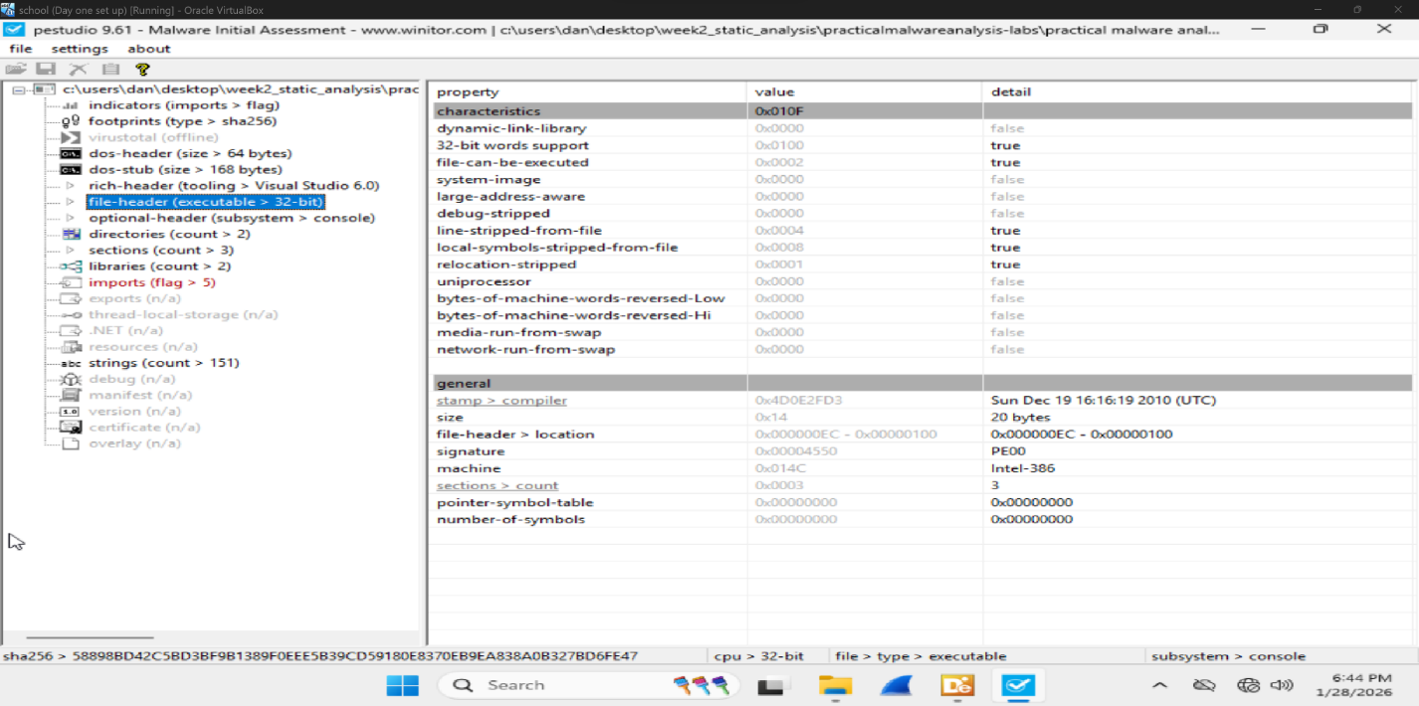
This PEStudio screen shows basic info about the file itself. The file has a PE00 signature, which means it is a real Windows program and not a broken or fake file. It is made for Intel 32-bit systems, so it is meant to run on older or 32-bit versions of Windows. The file is marked as executable, which tells us it is designed to be run like a normal program. It is also not a system file, so it does not need special system permissions. The header also shows that extra debugging information was removed. This means the program was built to be used, not to be easily taken apart or tested. This is normal for regular software, but malware often does this too to make it harder to look at.

Detect It Easy:
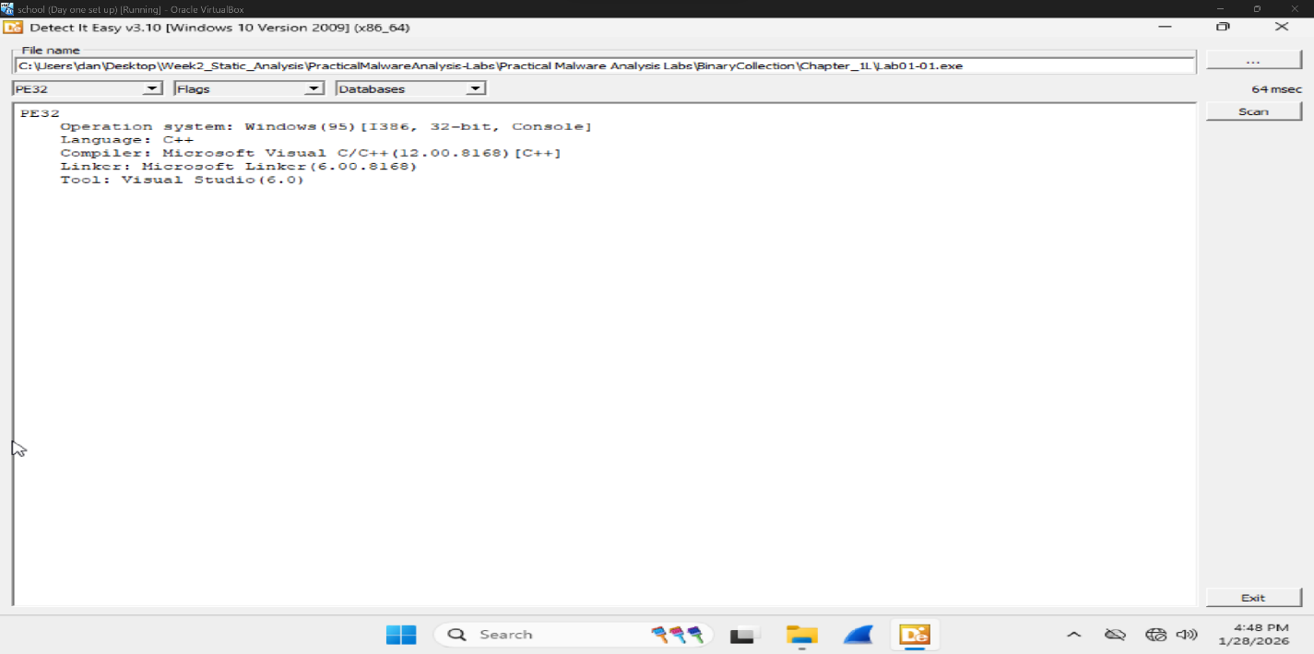
Detect It Easy (DIE) was used to see how the file was made. The scan shows that the file is a 32-bit Windows program that runs in a console window. It was written in C++ and built using Microsoft Visual Studio 6.0 which is an old programming tool. DIE did not find any packers or obfuscation. This means the program is not trying to hide its code. This matches what was seen earlier like the low entropy value and readable strings. These results suggest the file is simple, easy to analyze and likely only does basic stuff.

Indicators of Compromise (IOC)
Based on the static analysis, there are a few important clues that help identify this file. The file analyzed is Lab01-01.exe, which is a 32-bit Windows program that runs in a command prompt window. The file also has a unique SHA-256 hash (58898BD42C5BD3BF9B1389F0EEE5B39CD59180E8370EB9EA838A0B327BD6FE47), which works like a fingerprint and can be used to recognize this exact file again. The program was found to use Windows functions like CreateFile, CopyFile, FindFirstFile, and FindNextFile. These functions mean the program can look through files on the computer and make copies of them. This gives a clue that the file works with the local file system. No internet related clues were found. There were no IP addresses, website links, or other network strings in the file. This points to the program does not try to connect to the internet. Overall, these clues show that the file mainly works with files on the computer instead of using the network.

Risk Assessment
Based on the static analysis results of this file alone, this file does not appear to be extremely dangerous but it is also not completely safe. The program does not show signs of connecting to the internet or communicating with outside systems which lowers the risk of data theft or remote control. However the imports and strings show that the file can create, copy, and search for files on the system. This behavior could be used to repeatedly create or copy files which may slowly fill up disk space or reduce system performance over time. Even though this is not as harmful as ransomware or spyware it could still cause problems for a computer if allowed to run. To know for sure what the file actually does when it runs dynamic analysis would be needed. Running the program in a controlled environment would help determine whether it performs harmless actions or shows more harmful behavior. For these reasons the file should be treated as suspicious and not considered safe until testing it. Based on static analysis alone, this file appears low-risk but still suspicious

References
Sikorski, M., & Honig, A. (2012). Practical Malware Analysis: The Hands-On Guide to Dissecting Malicious Software. No Starch Press.
Winitor. (n.d.). PEStudio – The Portable Executable Analysis Tool. Retrieved from https://www.winitor.com

